Problem Statement 1

Write a Java program, to take a HDFS Path as input and display all the files and sub-directories in that HDFS path.

Code:

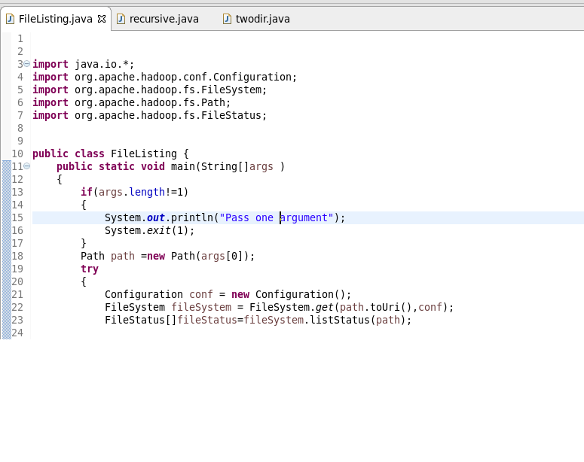

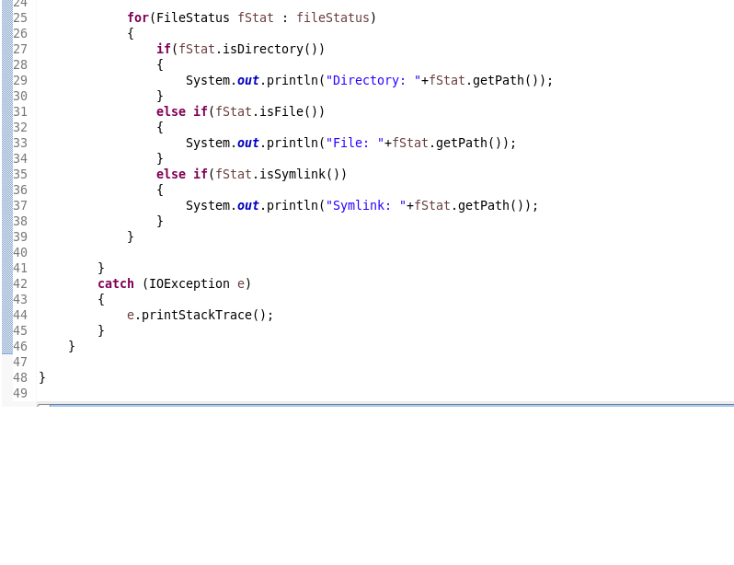

Output:

